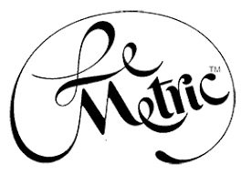

Phone:
E-mail: Website:

Makeover in a Connecticut Minute

Change your hair and change your life

Newtown, CT, March 2 – Hair has the ability to change the way women feel about themselves. Elline Surianello, Founder and CEO of The LeMetric Hair Studio, knows exactly what that means, because she herself experienced losing her hair in 1984. Traditional wigs were not cutting it and she knew there had to be an alternative. Elline understood that hair and beauty have to evolve as we do. She started Le Metric to be able to provide nontraditional hair that you can wash and live in as if it were your own hair.
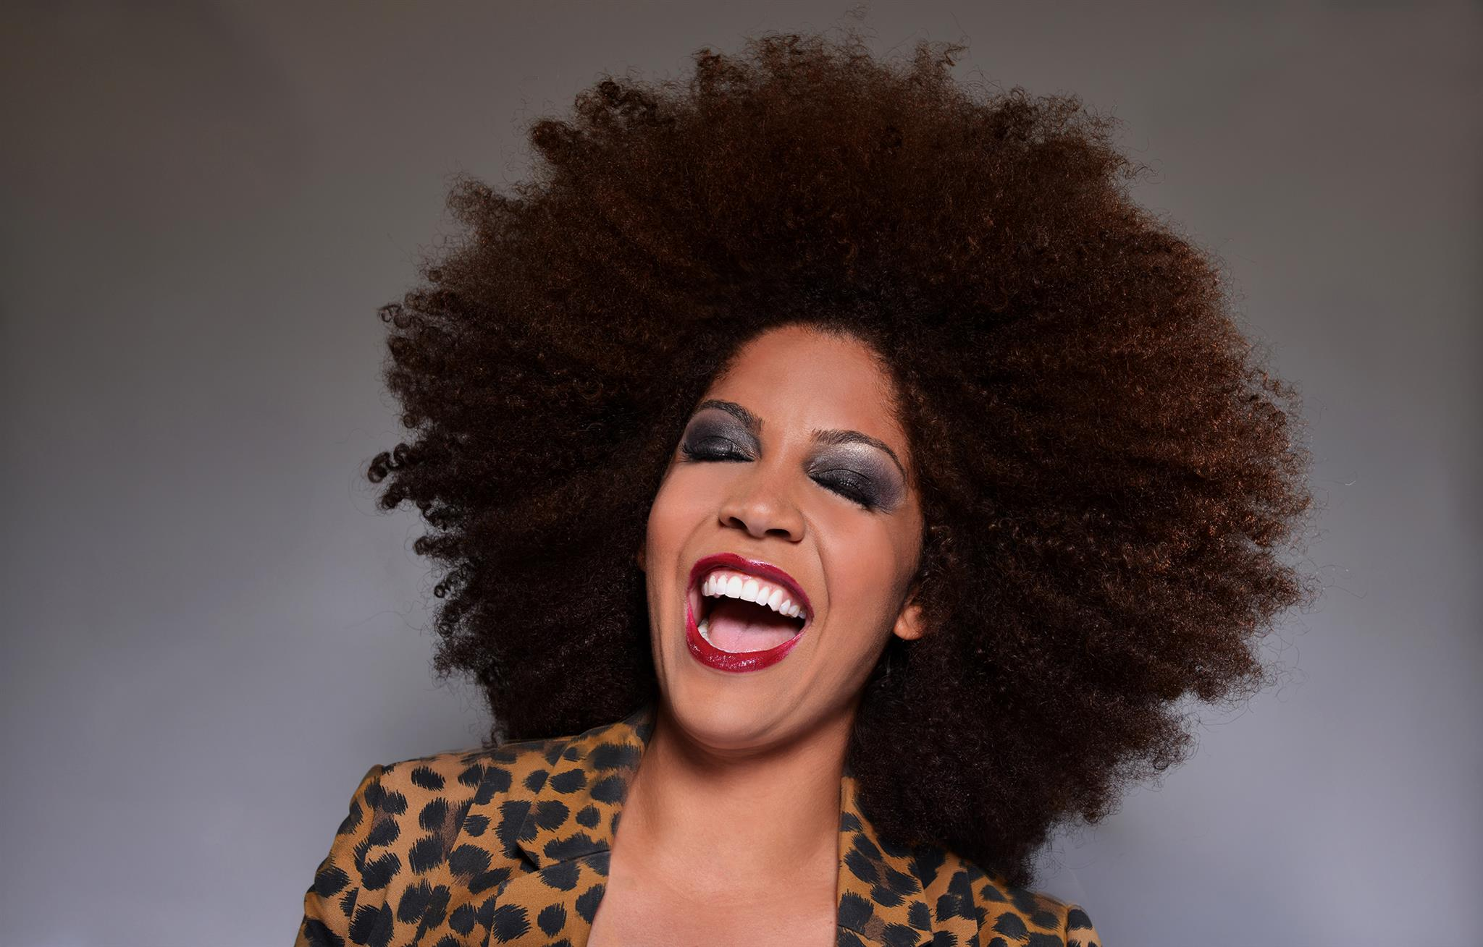
She explains in The LeMetric Real World Hair Makeover Photoshoot video, “When I started LeMetric in ’89, my goal was to deliver to you, the consumer, the best possible product and service available to women because I knew how uncomfortable wigs and inserts were.” That is why the materials used to create the hair are the best quality that there is.

Feel good about your hair with LeMetric's help.

--more--

Makeover in a Connecticut Minute Page 2

The video is a small example of the different messages we, as women, convey and how powerful transitions can be. Hair changes how we look and how we feel and Elline’s goal is to help women around the world who need a change. That is why, starting in May 2018, she is going on the road with her mobile to a town near you. She wants to let women see what they could look like without a big commitment or a huge price tag. If you have thinning hair or just need a new look, she and her team will work with you to create your new self-image. Life has challenges and sometimes we need a little help and support. Join her as she begins her US tour with her mobile. Free consultations are available.

If you are interested in more information about these services, please call x.

LeMetric can make a difference in your appearance. Photos by Abiel Ruiz

